**Deployment Walkthru Scenarios:**

After deploying the solution follow the below steps.

**Role: Administrator**

1. Loggedin as administrator role using teams client app.
2. Selected the Proposal Manager team -> General -> Configuration channel
3. “Permission” tab – Created all the permission based on ADGroupName.

Note: while creating new permission the “AdGroup Name” should be exist in O365

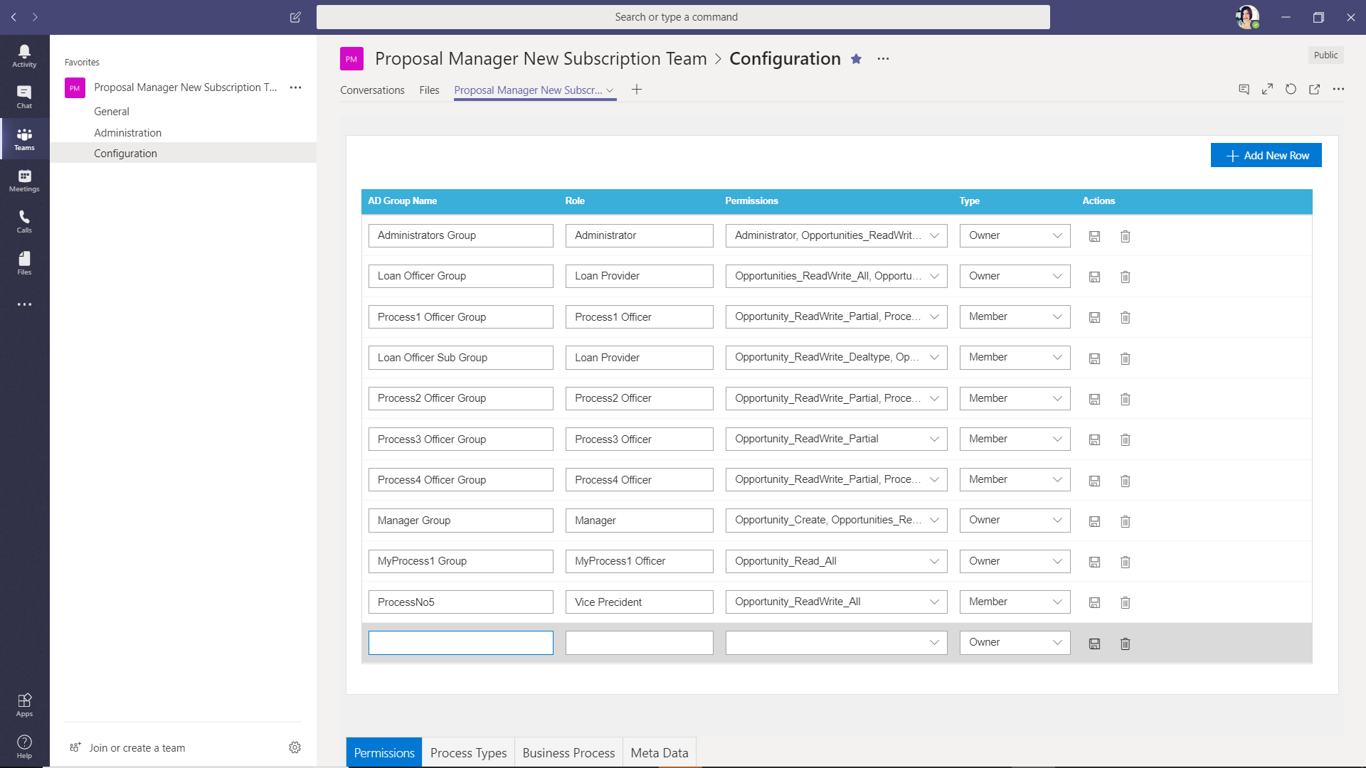

1. “Process Type” tab – created “Process Types” and assigned to different “Role Name”

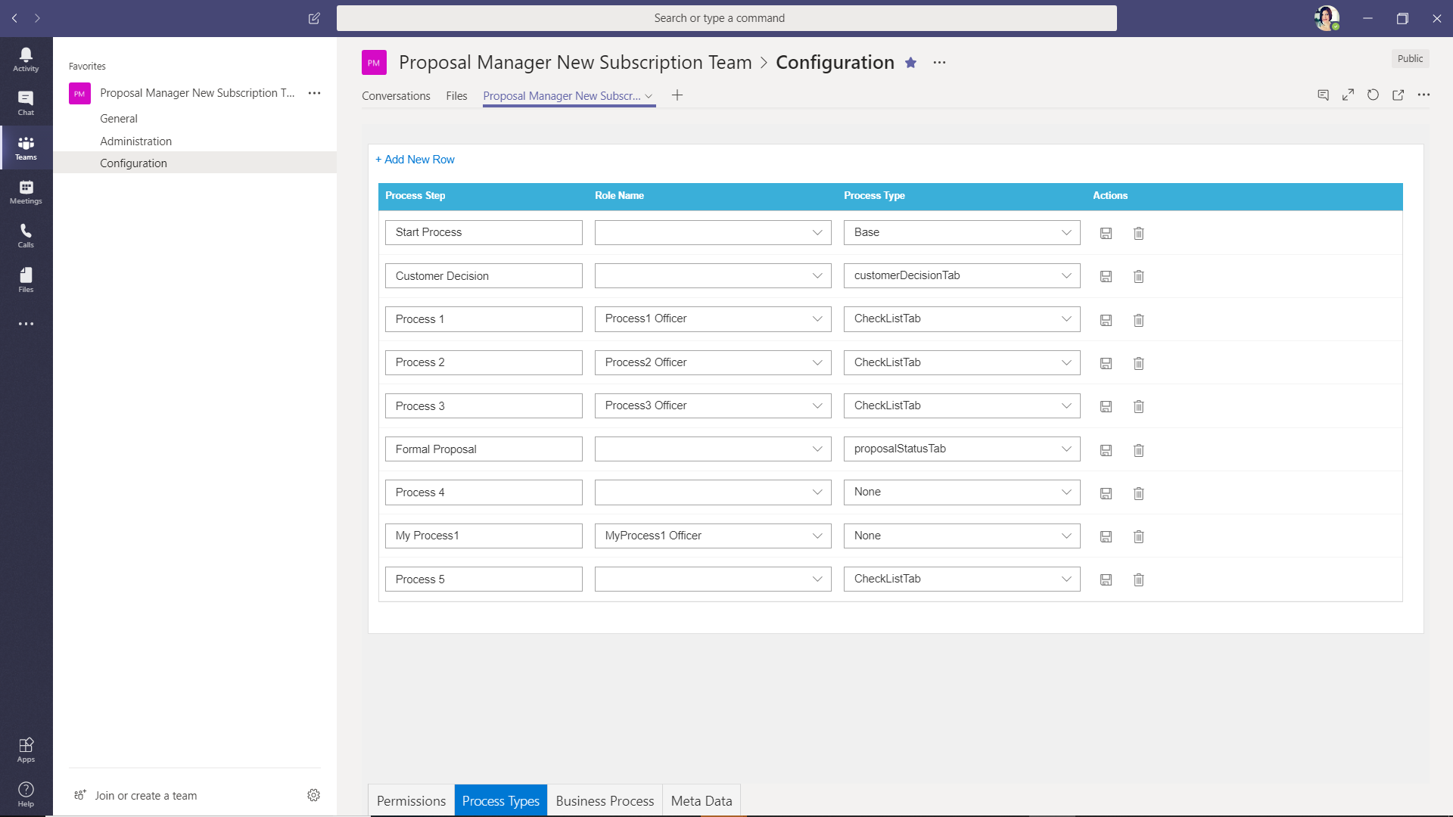

1. “Business Process” Tab – Created New template by clicking “Add” button from list page

“Template Ind” created successfully.

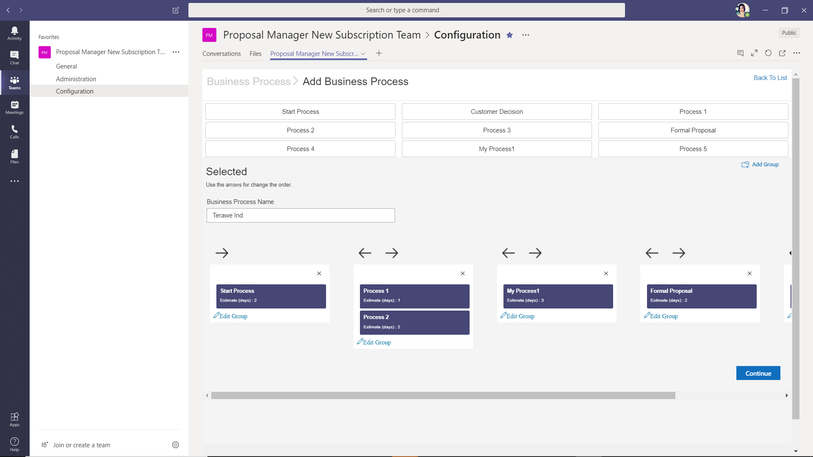

1. “Meta Data” Tab – Added new fields for Opportunity creation.

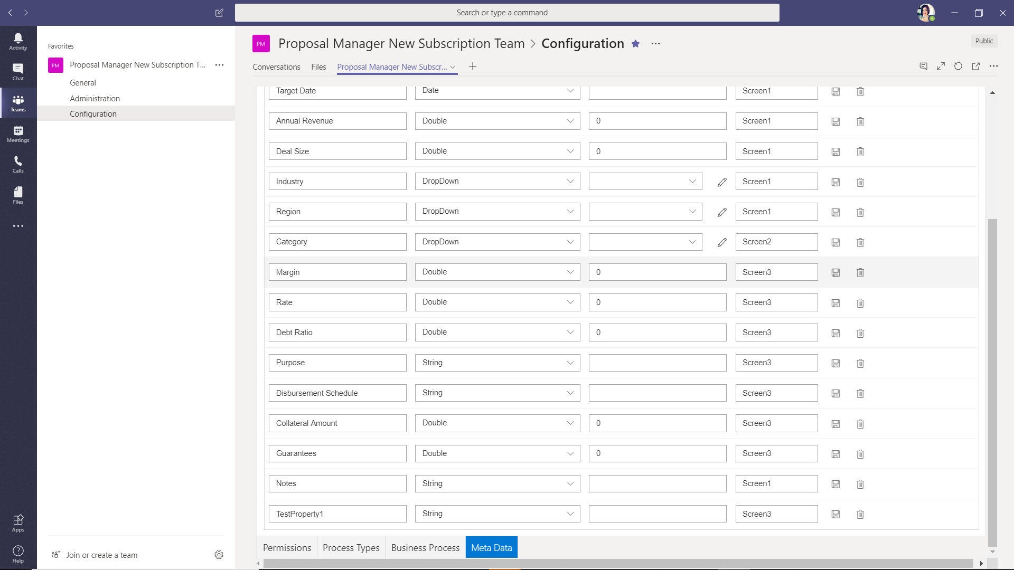

User logged-in with “Opportunity_Create” permission

1. Loggedin with user who is having “Opportunity_Create” permission, in this “Manager Group” user has “Opportunity_Create” permission
2. After login accessed general Proposal Manager team -> “General” channel -> Clicked on “Create New” button

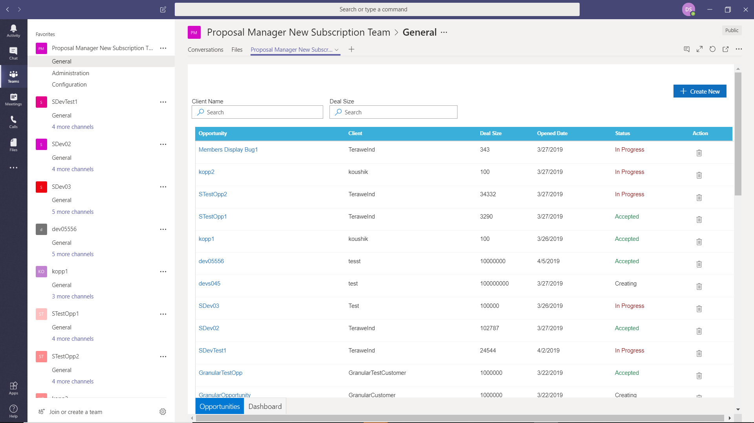

1. New Opportunity creation – Entered data in all step1/2/3

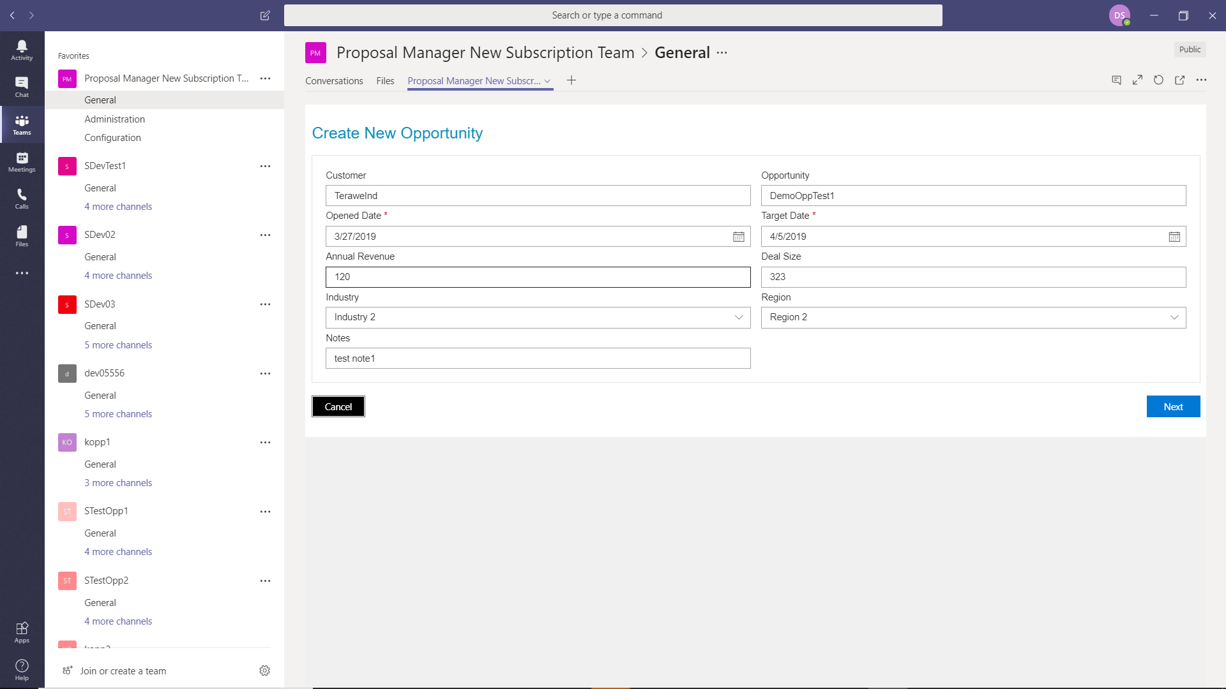

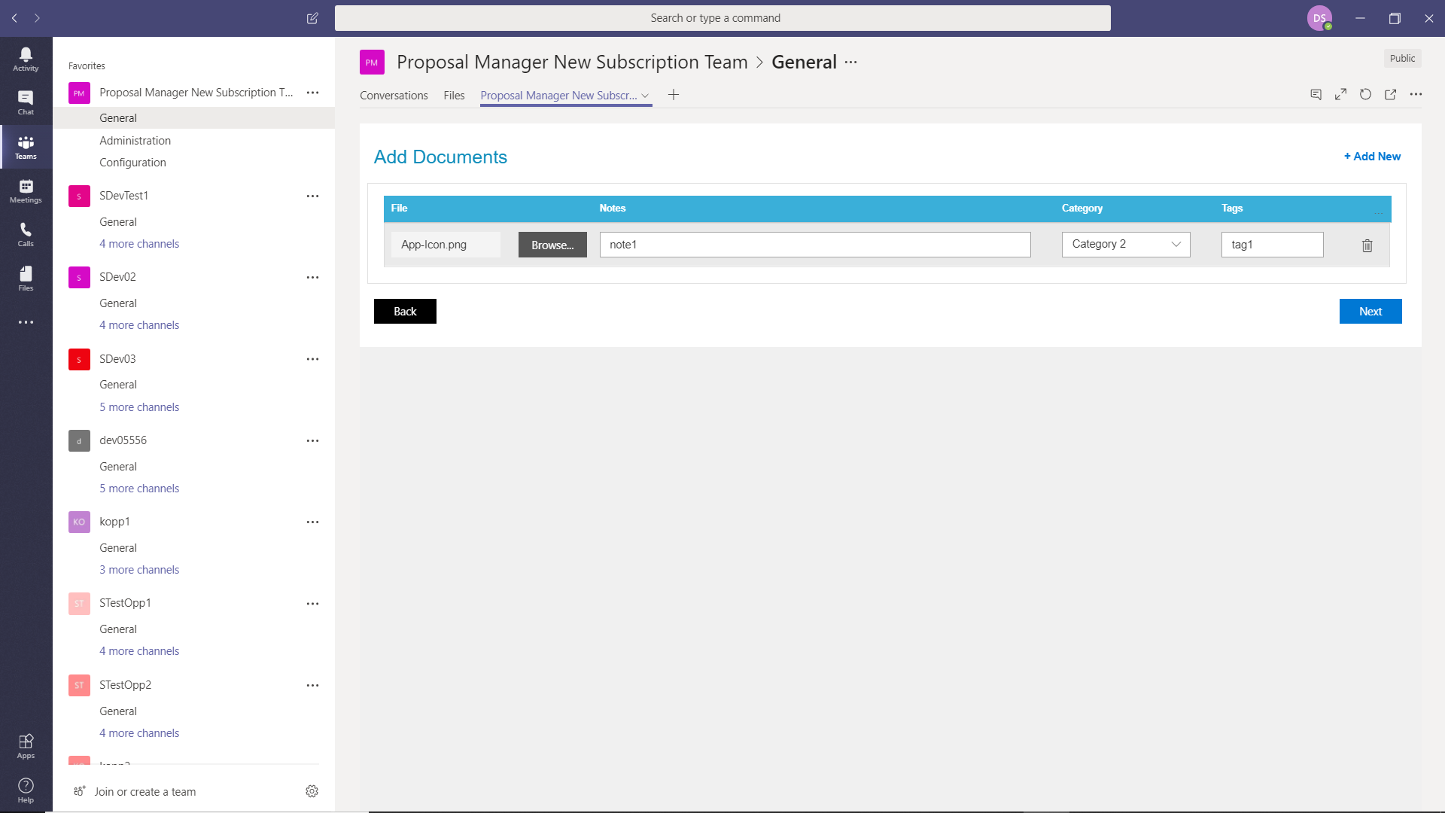

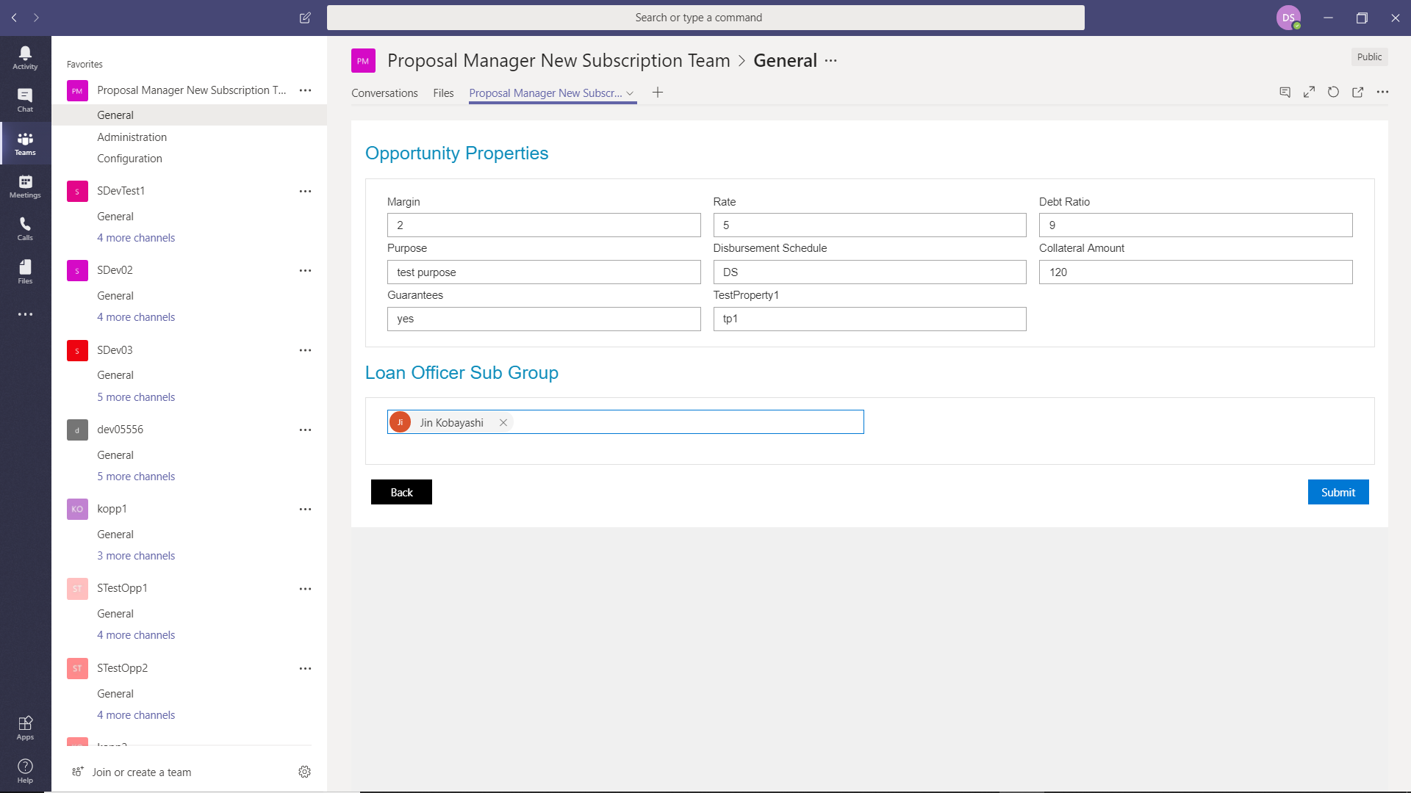

Opportunity Created successfully.

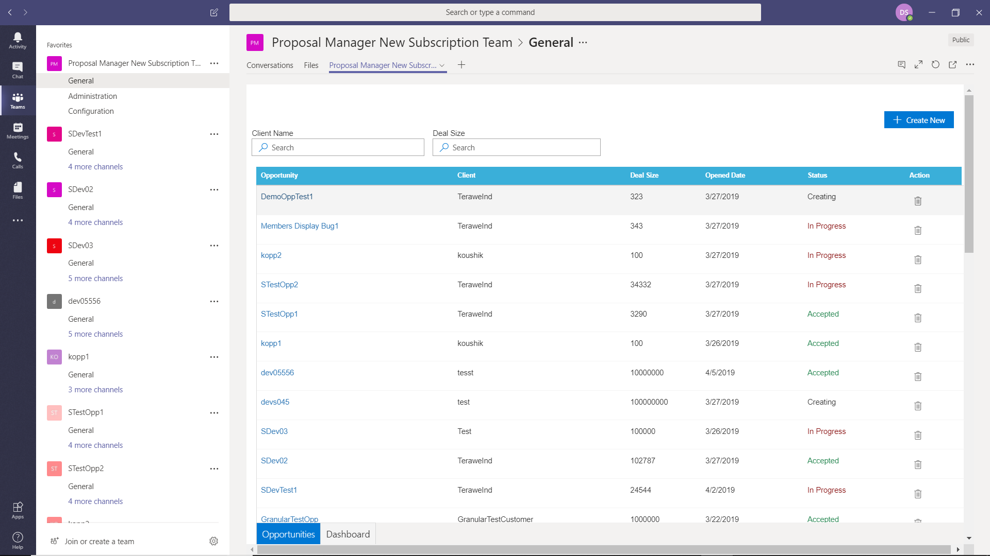

1. Loggedin as user who is having permission “Opportunity_ReadWrite_DealType” user -> Selected general proposal manager team -> General channel -> clicked on newly created opportunity name

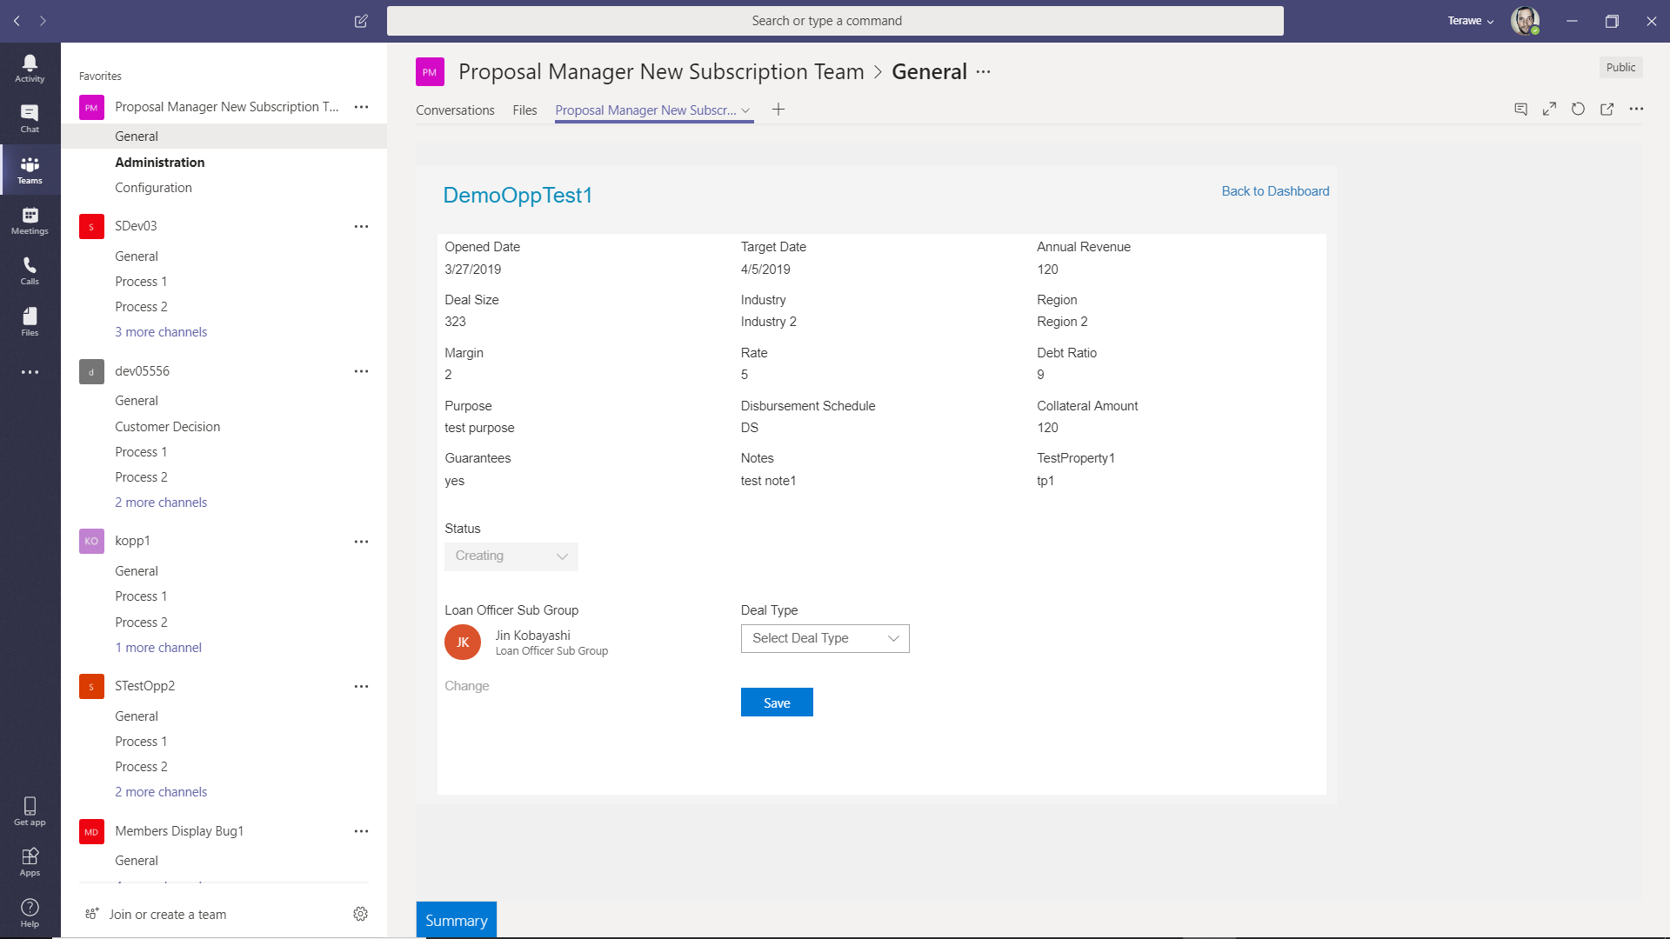

1. Selected the Template “Terawe Ind” -> clicked on Save button

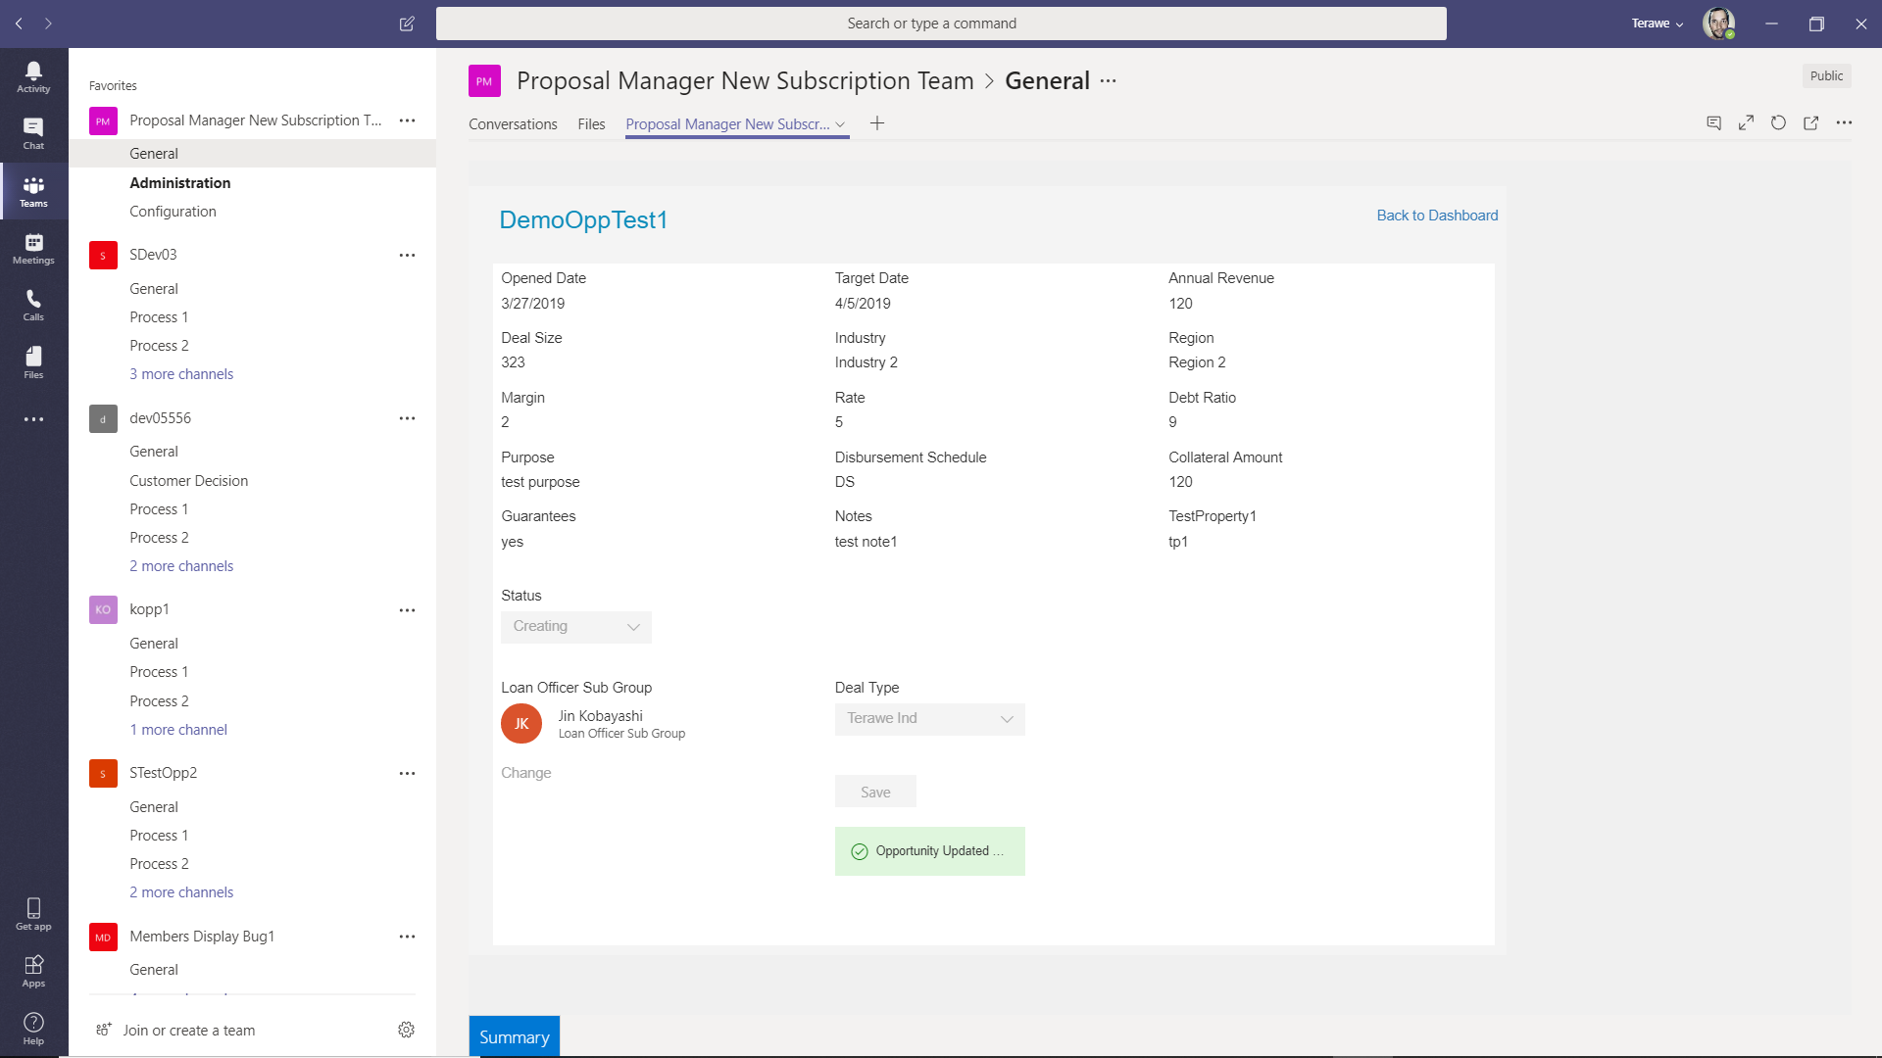

1. After selecting the Template -> Opportunity team and channels are created in teams.

Also “Proposal Manager” Tab also added to all channels

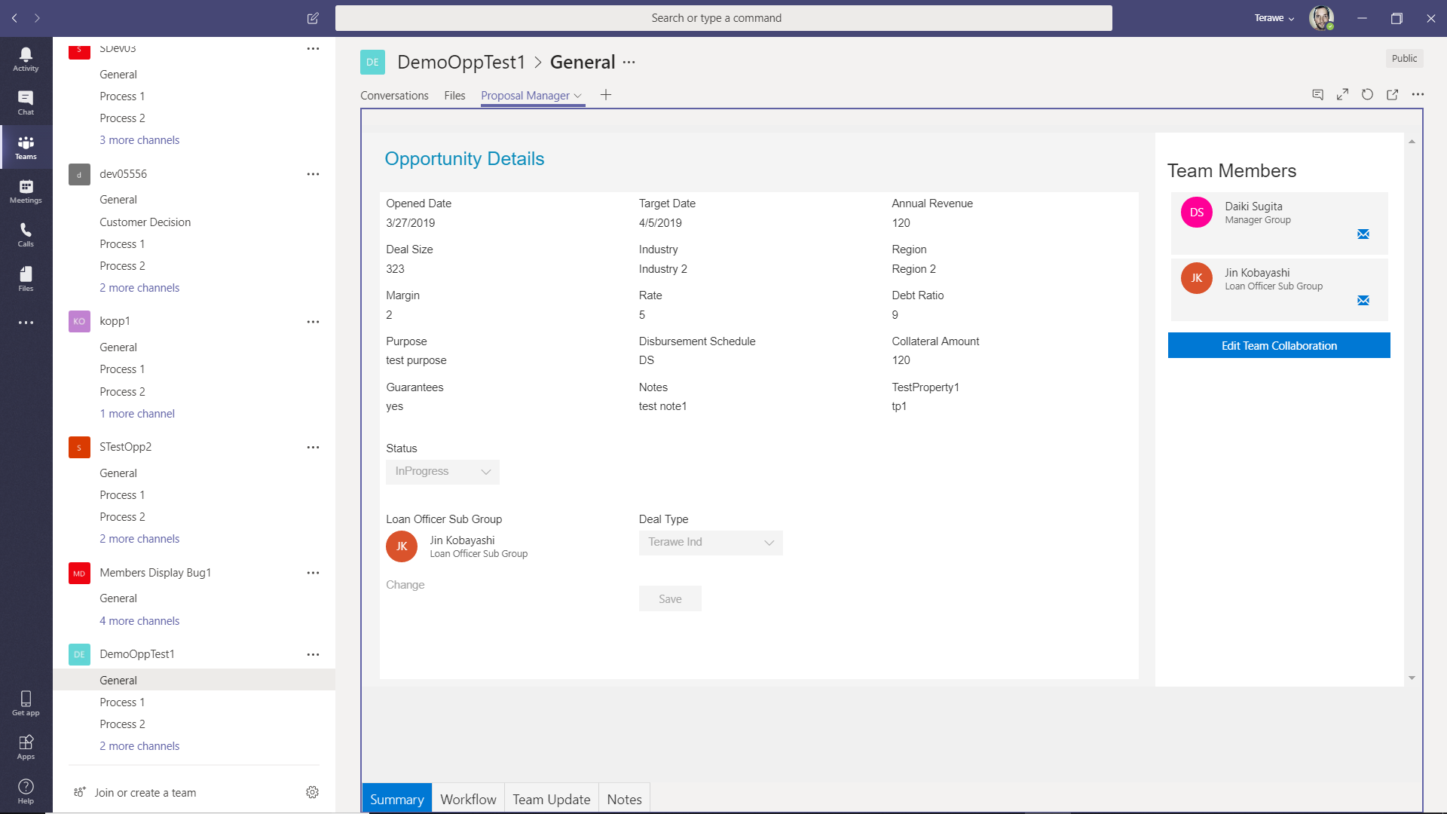

**Opportunity Level**

1. Loggedin user with “Opportunity_Create” permission -> Accessed Newly created opportunity team -> General

User can view the opportunity data by Tabs “Summary”, “WorkFlow”, “TeamUpdate”, “Notes”

“Summary” - > Display all the opportunity detail and Team members at right side

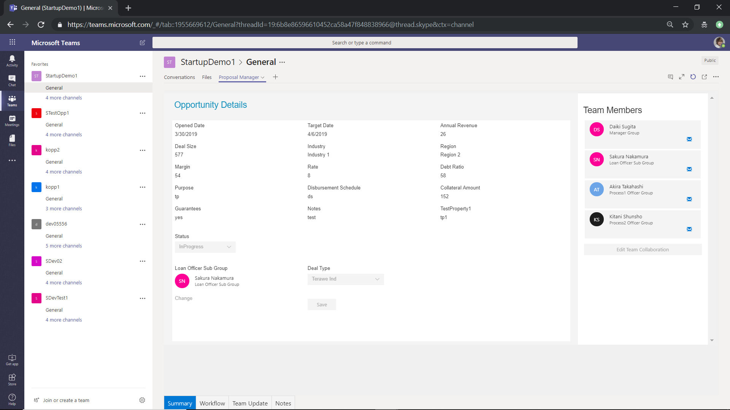

1. Workflow tab - > Based on selected “DealType” user can see all the process in workflow page. And also, can see the users if assigned to the process.

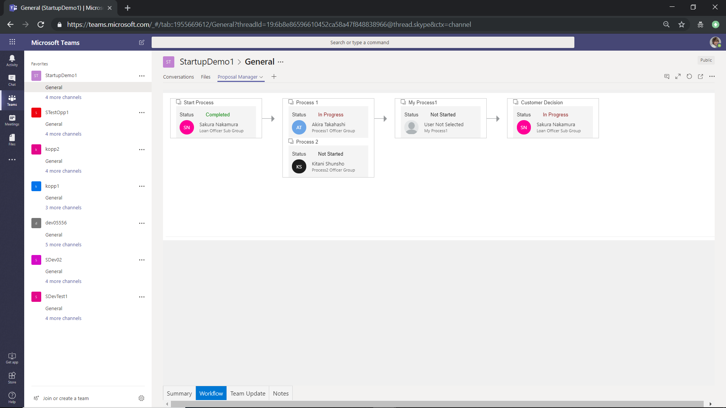

1. “Team Update” -> Display all the team members with persona card details for the process types. If user not selected will display “User not Selected” persona card

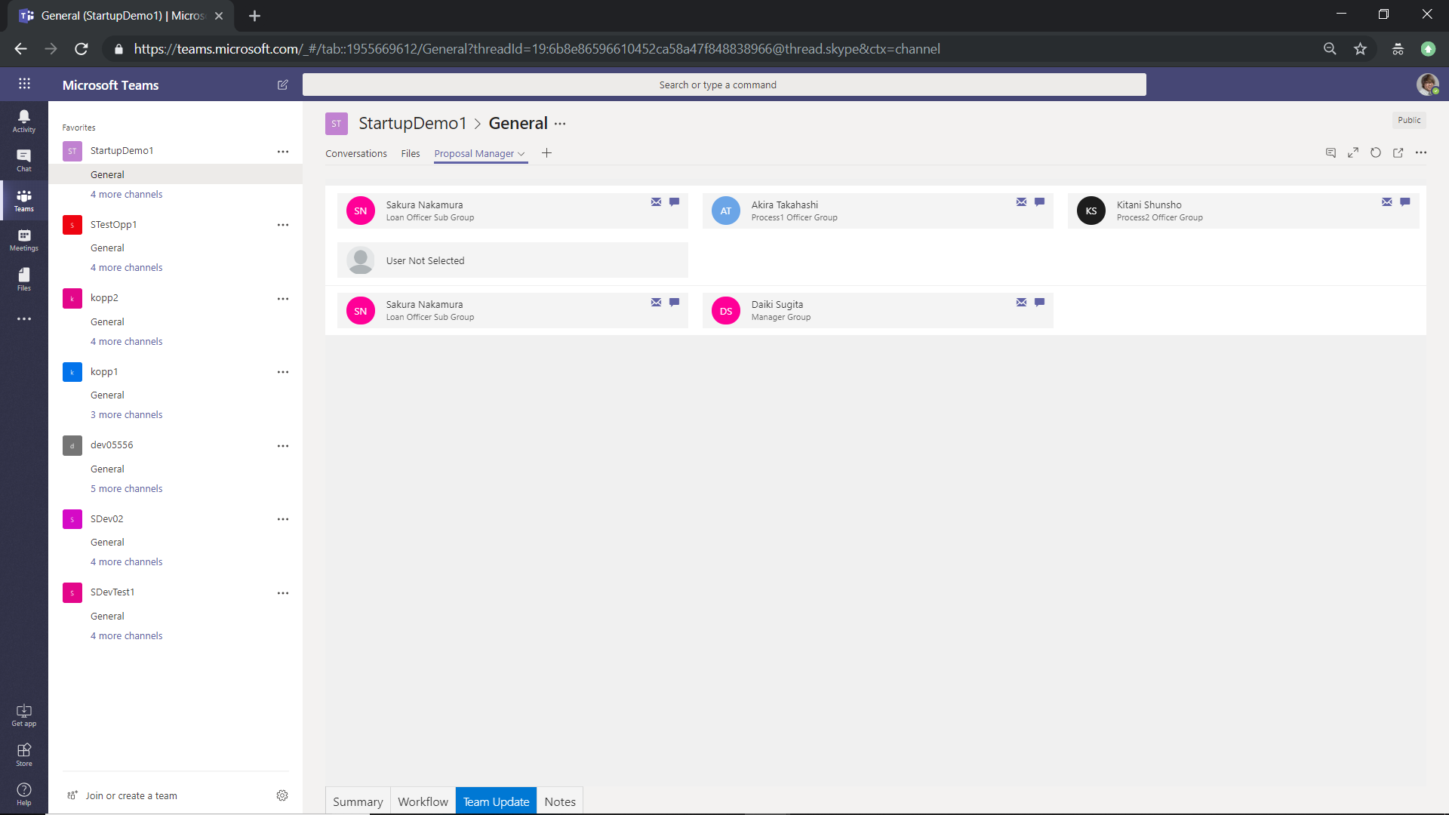

1. “Notes” Tab – Display all the notes entered in opportunity.

User can add notes by entering the text in “Textarea” and click on Send button

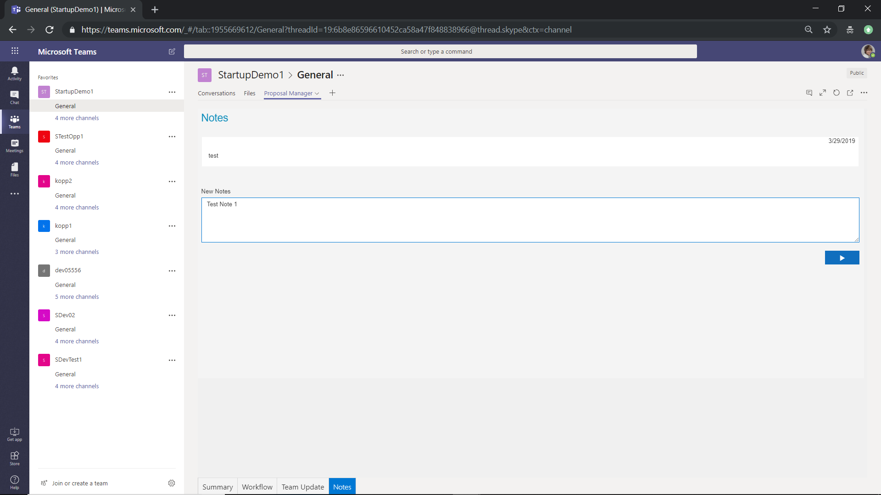

1. LoggedIn user with “Opportunity_ReadWrite_Team” permission -> Accessed Newly created opportunity team -> General

Display all the opportunity details in summary page and also right side “Edit Team Collaboration” button is enabled.

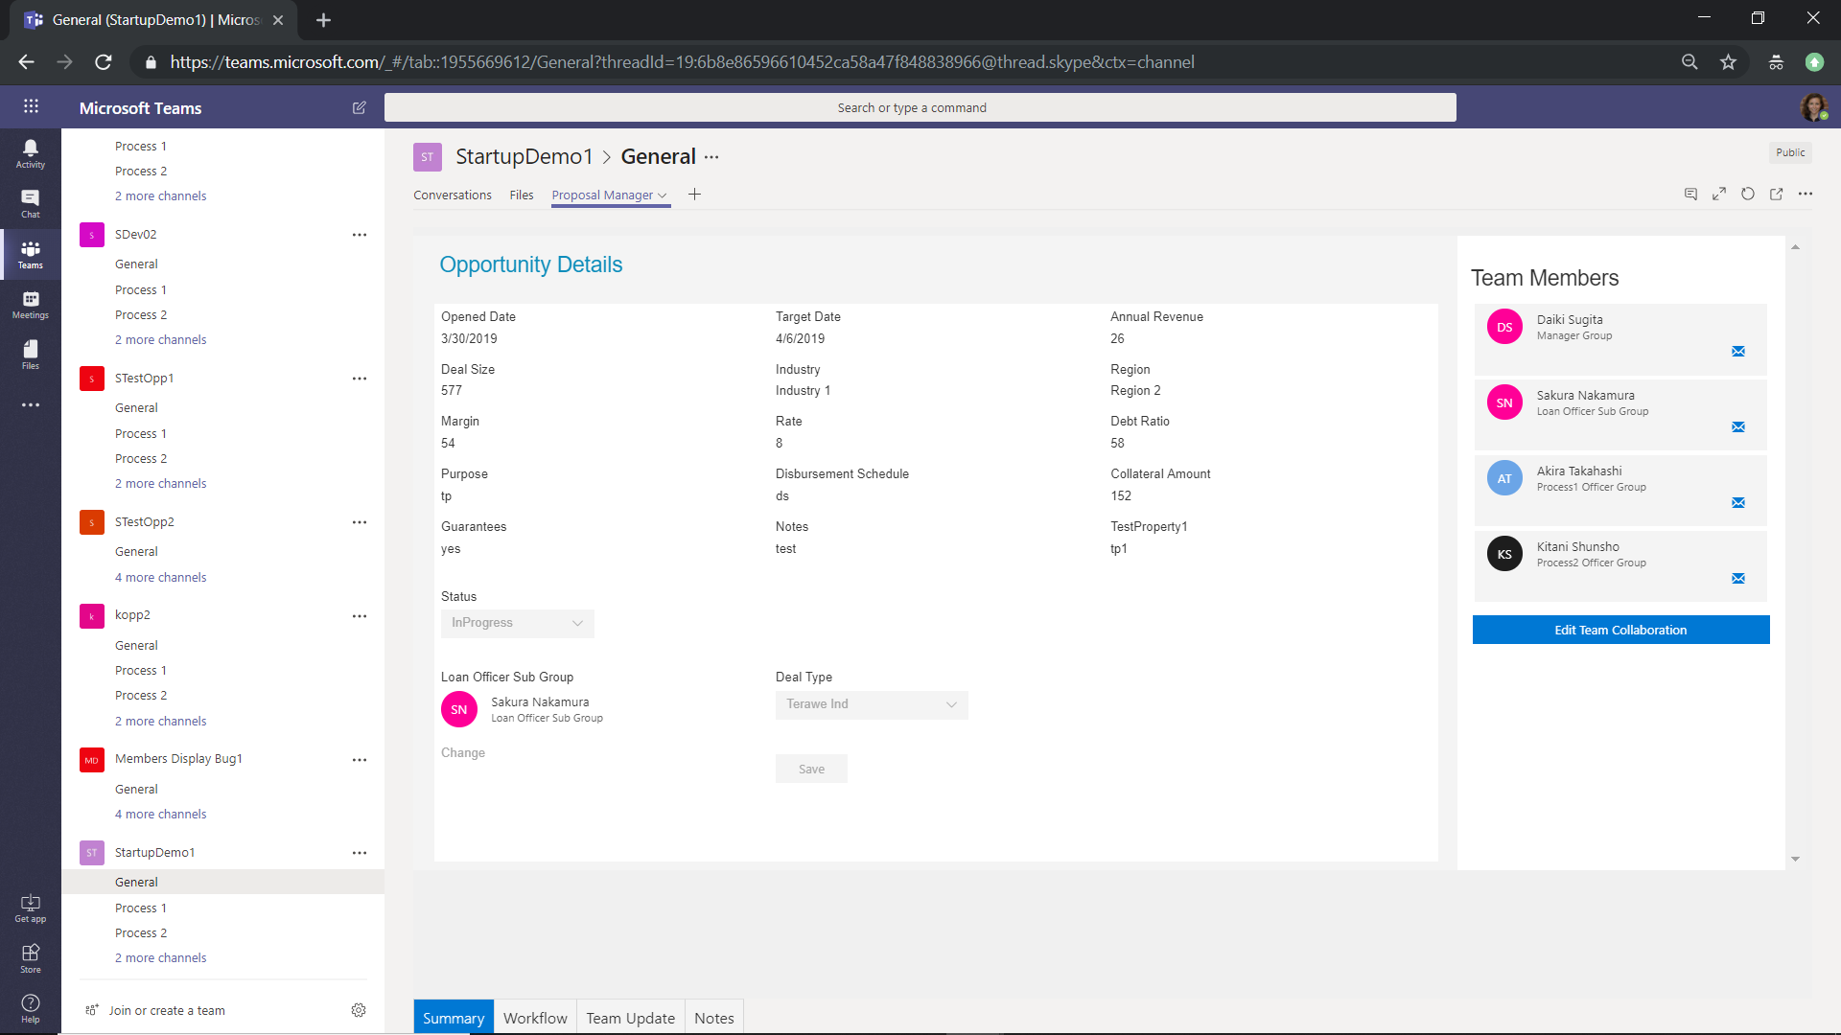

1. By Clicking on “Edit Team Collaboration” button user can select the team members for all Process types and click on “Finalize Team” -> will save the team members

Also user can select the Template document and click on Save button to upload the template. Once template is save user will see “View Document” link and save disabled.

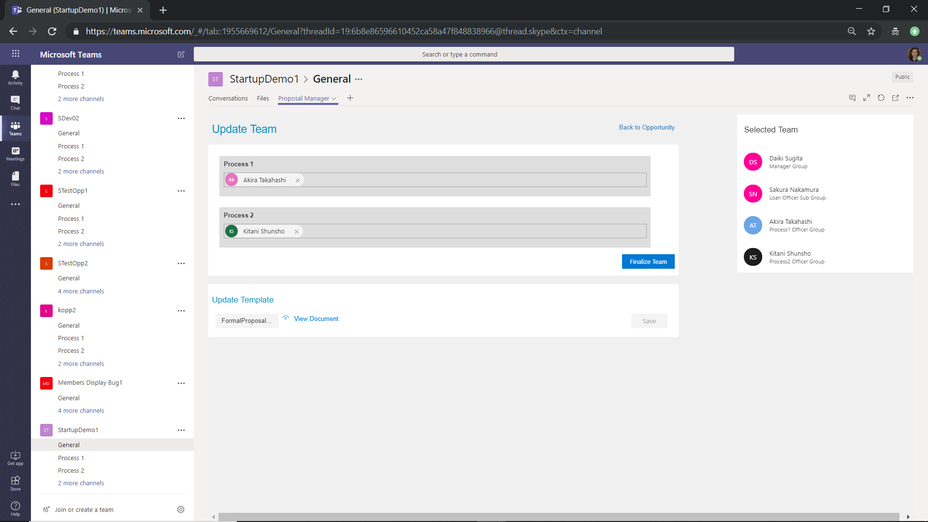

1. Accessed the “Formal Proposal” channel - > page will display the available sections present in the uploaded templated document.

User can assign the Owner for each sections and update the status details.

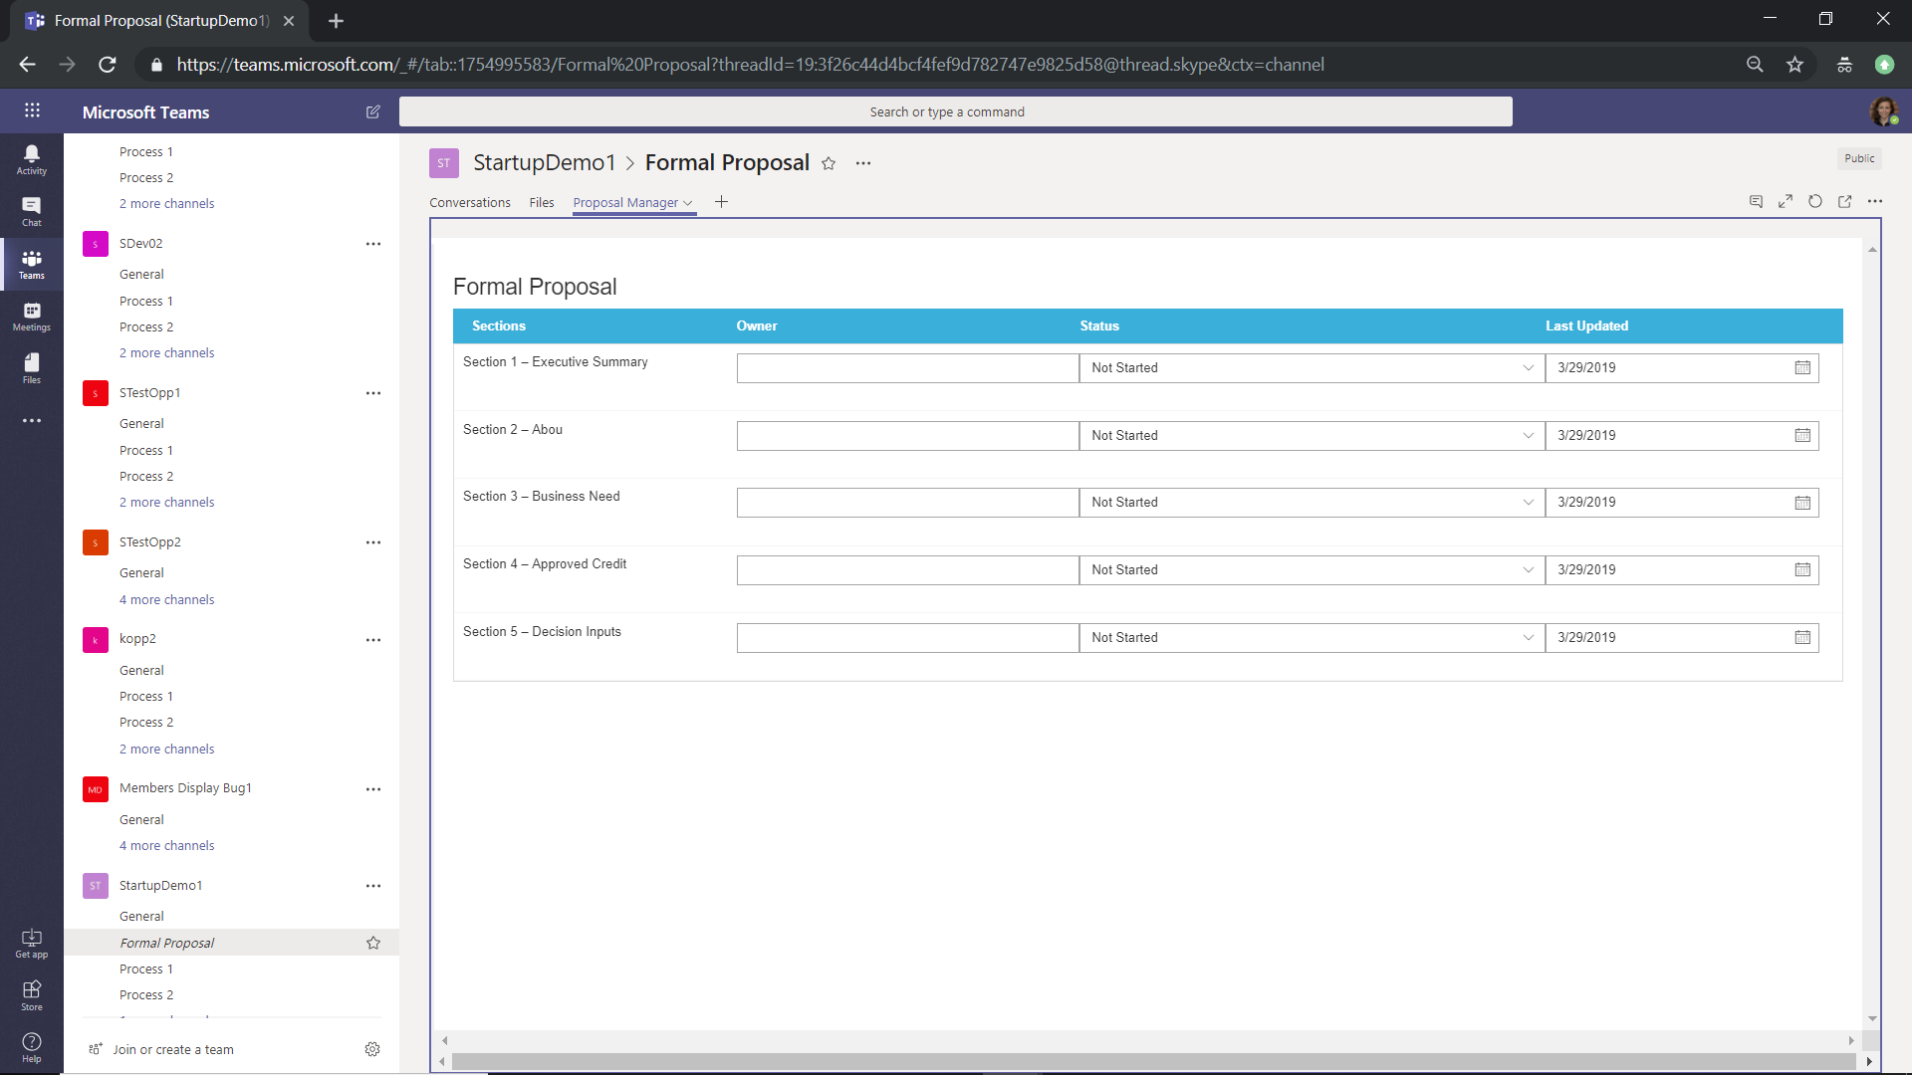

1. Accessed the “Customer Decision” channel -> User can update the details like Customer Approval, Approved Date, Loan Disbursed and Status.

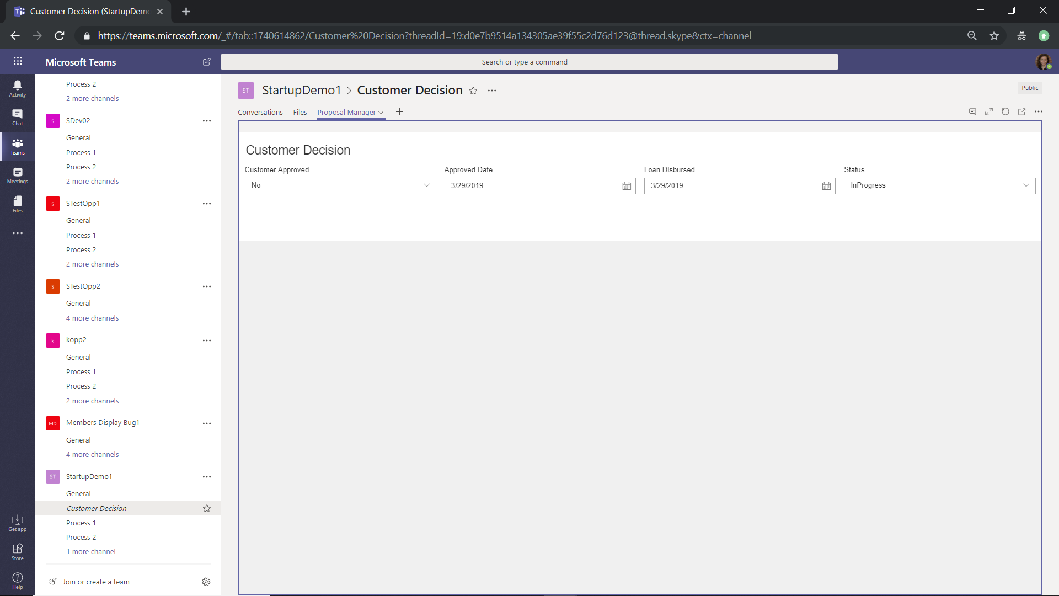

1. Loggedin user with “Process1_Read” permission -> Accessed Newly created opportunity team -> Accessed the “Process1” channel.

Displayed the checklist data, user can upload the check list items and upload the files. Also user can changes the status of the “Process1” channel. This status will reflect in Opportunity Workflow page.

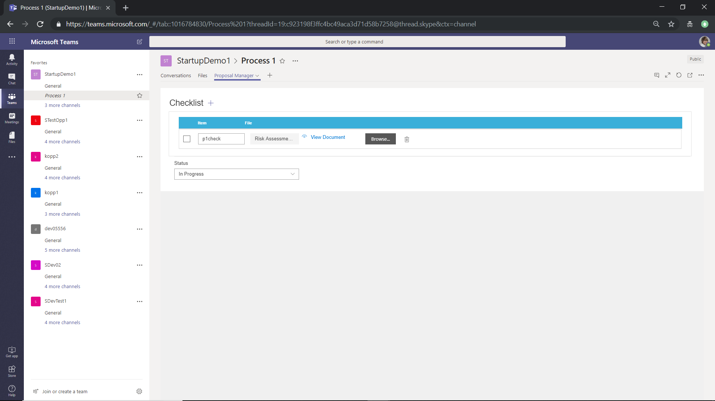

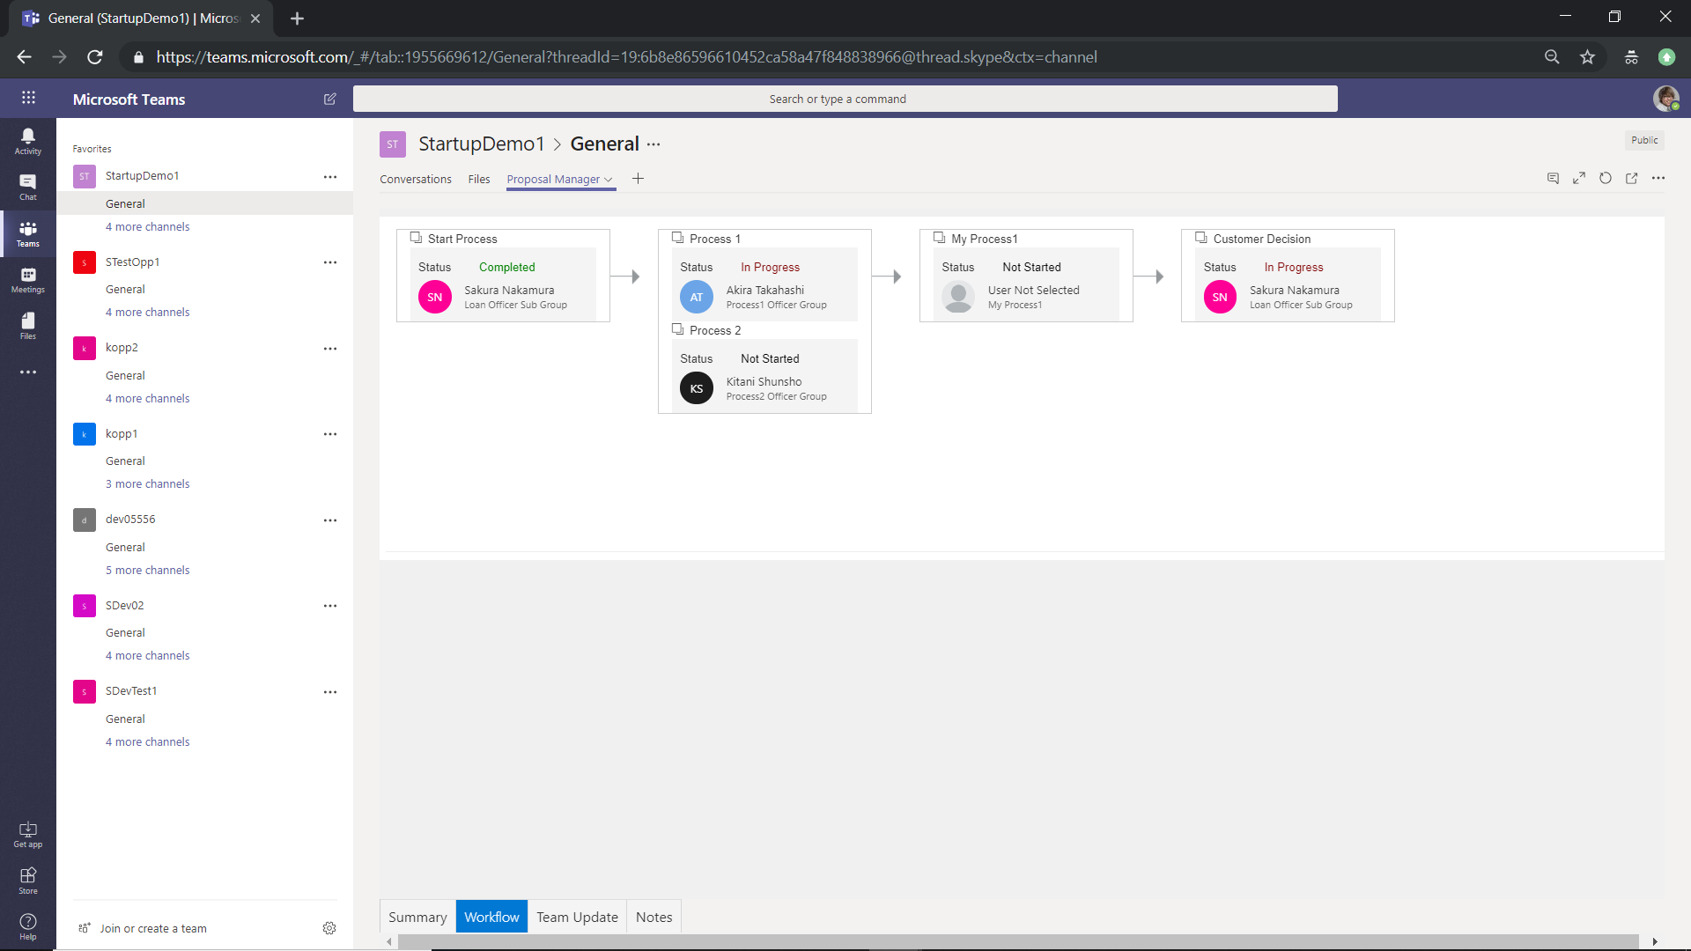

1. Loggedin user with “Process1_Write” permission -> Accessed Newly created opportunity team -> Accessed the “Process2” channel.

Will display a message “You don’t have access to this page. Please contact your Administrator”

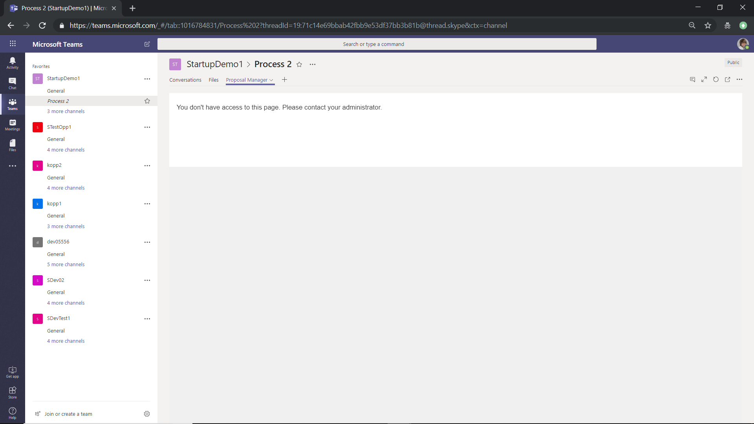

1. Loggedin user with “Process1_Write permission -> Accessed Newly created opportunity team -> Accessed the “Formal Proposal” & “Customer Decision” channel.

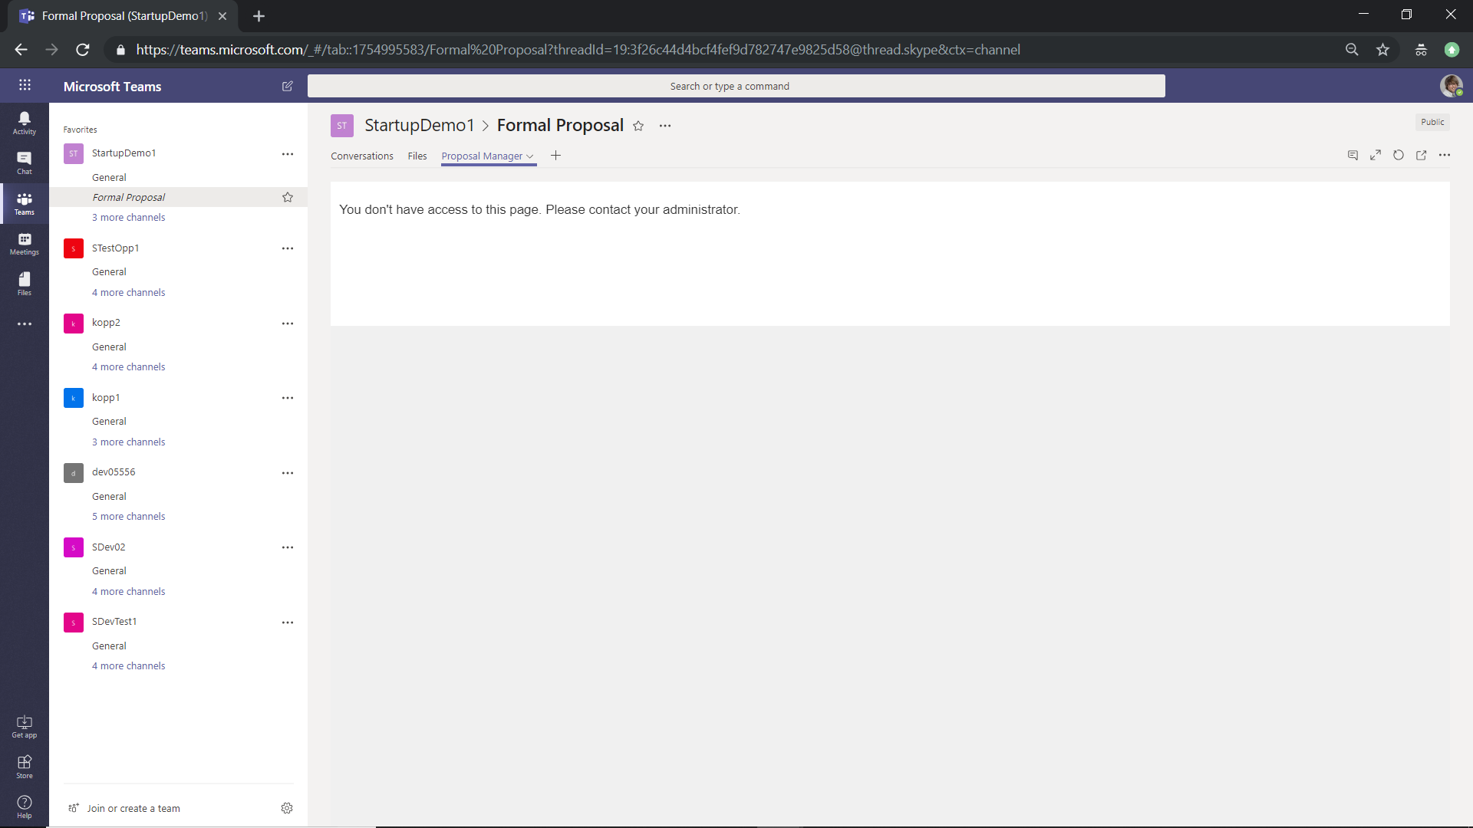

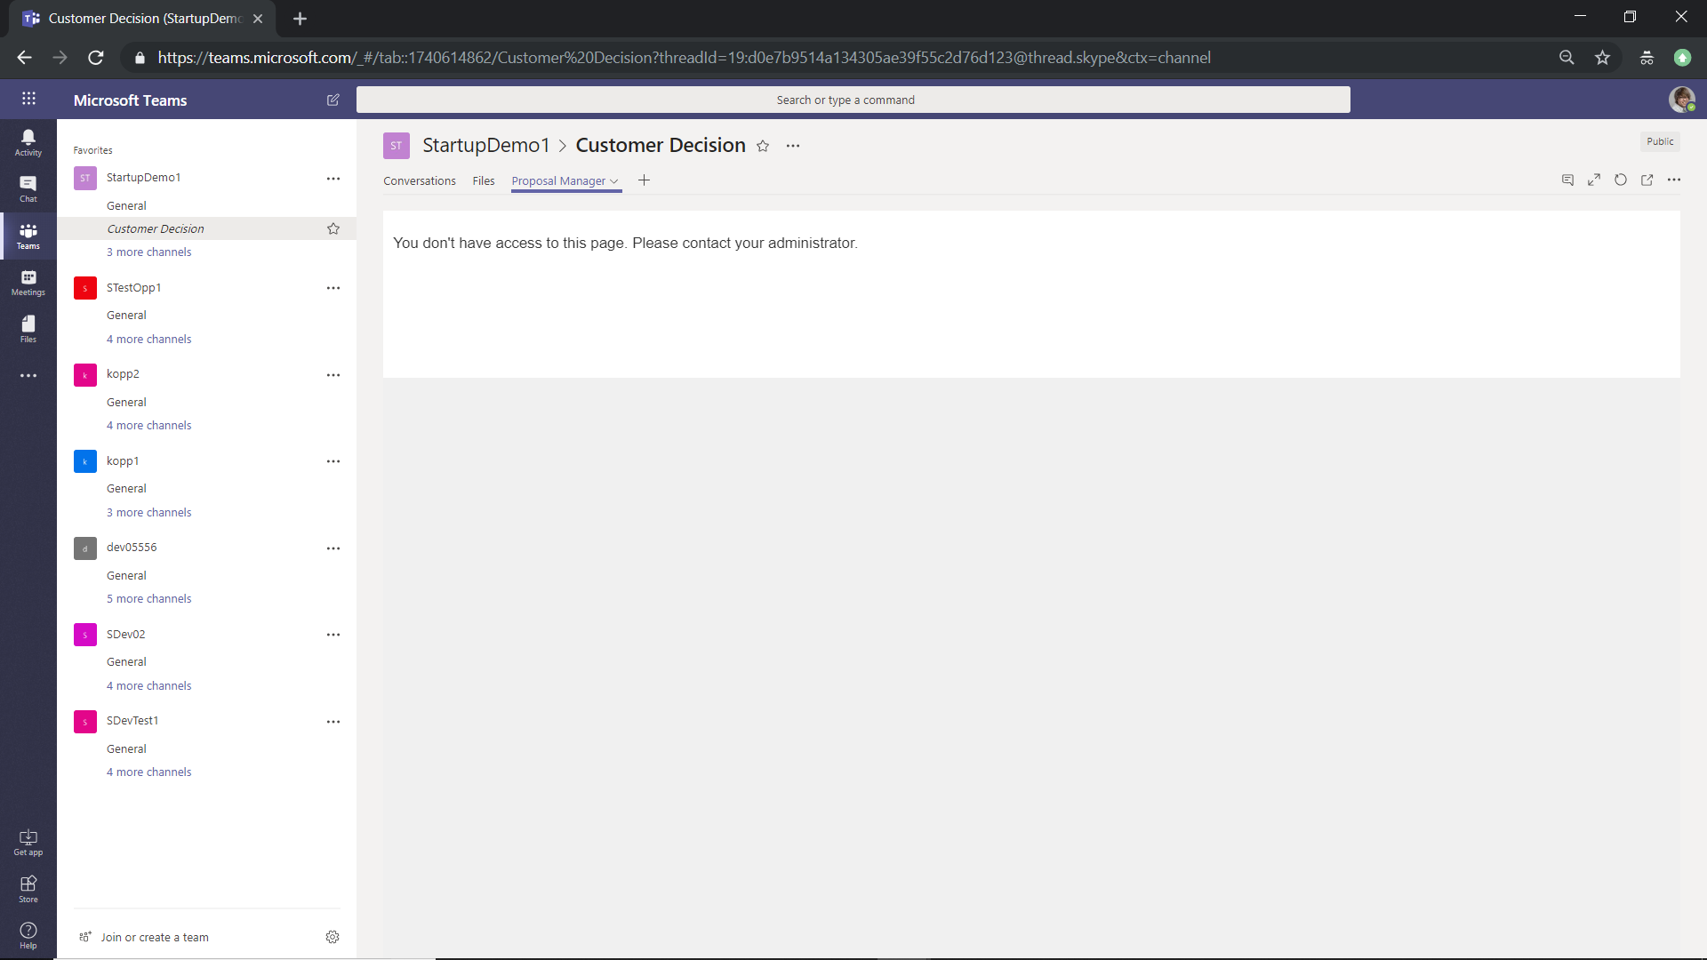

1. Loggedin user with “Process2_Read” permission -> Accessed Newly created opportunity team -> Accessed the “Process1” channel.

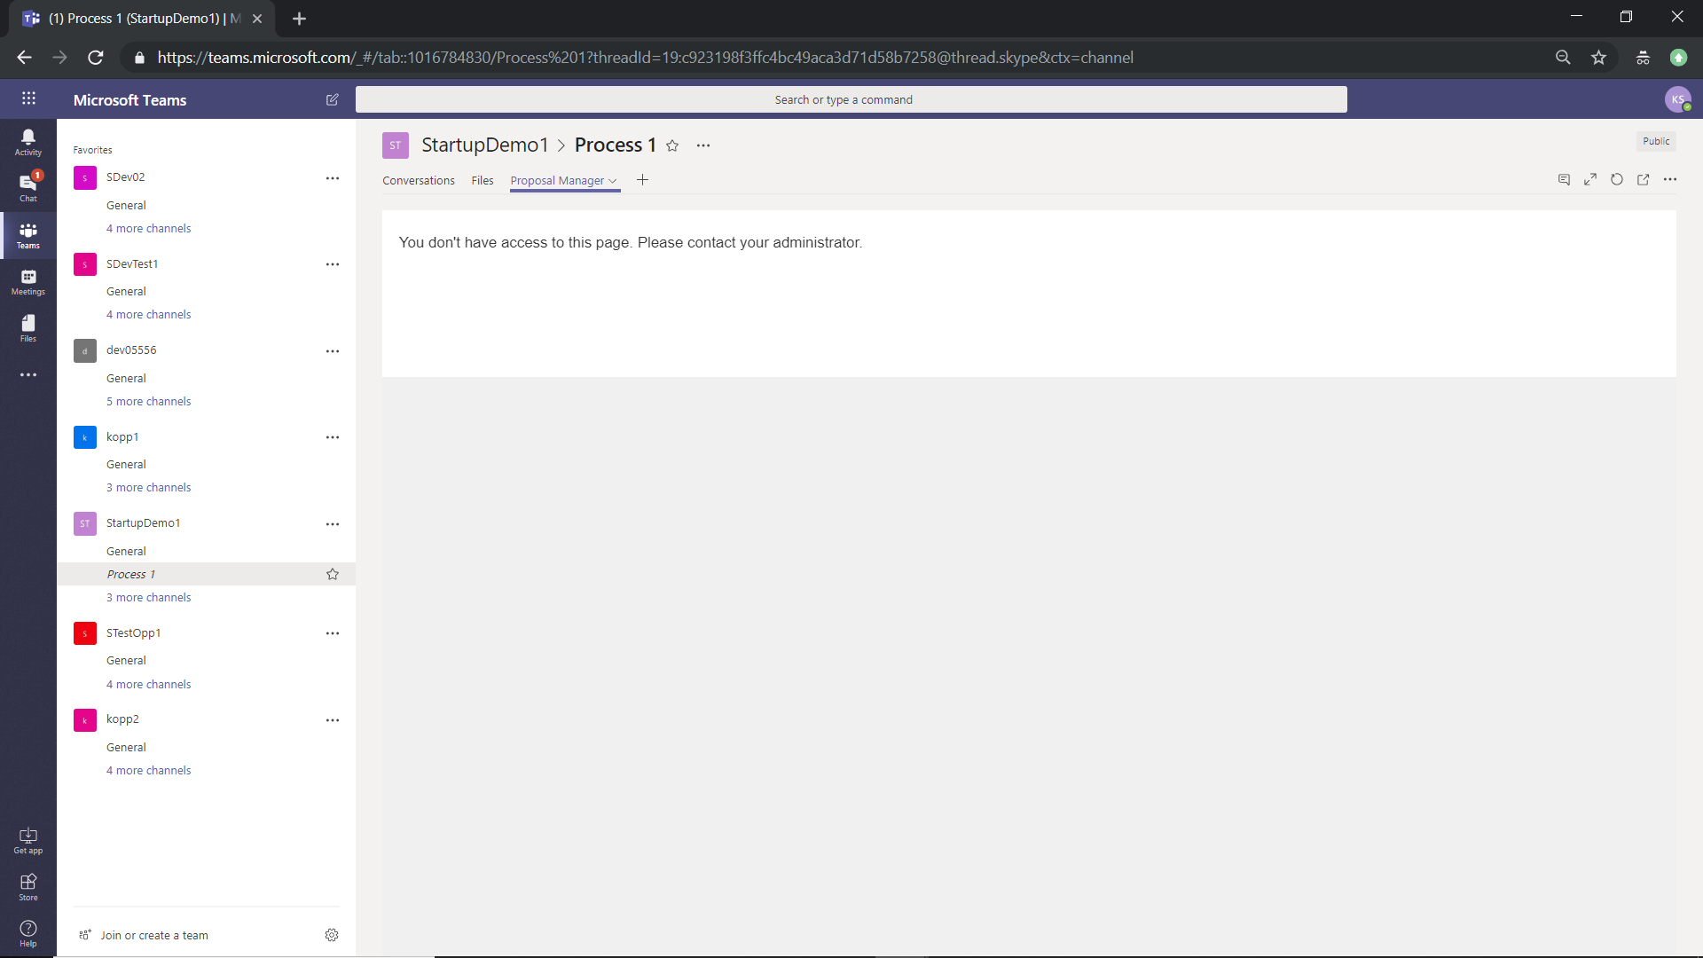

1. Loggedin user with “Process2_Read” permission -> Accessed Newly created opportunity team -> Accessed the “Process2” channel. Able to see the checklist item details for the “Process2”

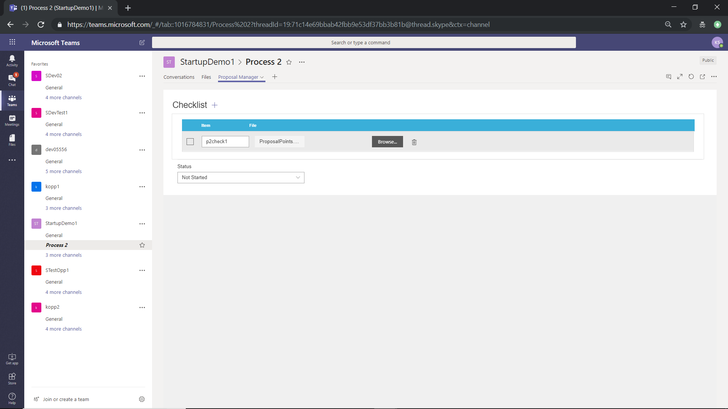

1. Loggedin user with “Process2_Read” permission -> Accessed Newly created opportunity team -> Accessed the “Formal Proposal” & “Customer Decision” channel

